KATSU-MI KAI SHOTOKAN KARATE
Membership Application Form
Section 1: Personal Details
First Name(s): | Date of Birth:
Surname(s): | Title:  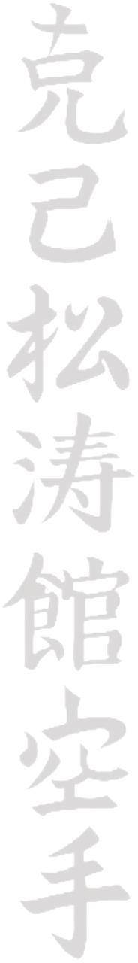  Mr Mrs Miss Ms Dr
Address: | Contact Phone Number(s):  Landline: Mobile:
Email Address | Occupation:
Grade KYU/KUP DAN
Section 2: Licence Details
Renewal/New Member New Renewal | Club and Instructor Name:  KATSU-MI KAI SHOTOKAN KARATE  MARK CARROLL
Current Licence Expiry Date: | Current Licence Number:
C.M.A.A. Members are automatically covered by our group member/member and public liability insurance so long as your licence is in date

THIS IS NOT A PERSONAL INJURY POLICY. It provides cover in the event that you should damage property or injure another student during training. It will NOT pay benefits should you be off work for a length of time as a result of an injury sustained during training. For further information contact C.M.A.A
Have you or do you have any serious illness? Have you ever suffered any serious injury?
I the trainee indemnify the above club/association in respect of any injury caused to another member or against losses caused to the club by any act of mine or default. I the trainee understand that the training and practice of the martial arts can be dangerous and I agree personally to bear all losses caused by injury whilst engaged in it.
NOTE: You are reminded of the C.M.A.A. bylaws which state that the annual renewal of the licence is your responsibility and that out of date applications will be back dated
I agree whilst I am a member of the above named club/association within Cobra Martial Arts Association that this form will be signed every year and will be acceptable for further licensing applications, which will be shown in my licence book.
SIGNATURE(under 18 parent only) DATE Please make cheques payable to M. Carroll

