KATSU-MI KAI SHOTOKAN KARATE
Licence Application Form/Student Declaration
Section 1: Personal Details
First Name(s): |  |  | Date of Birth:
Surname(s): |  |  | Title:  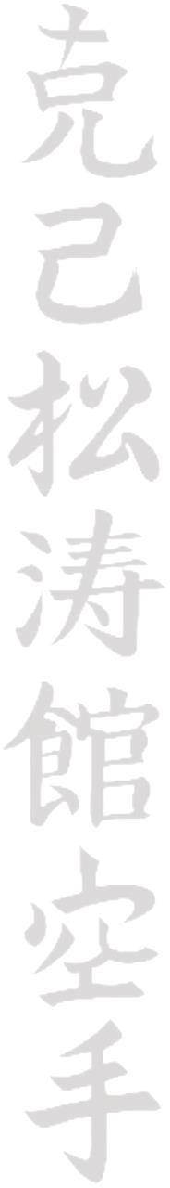  Mr Mrs Miss Ms Dr
Address: |  |  | Contact Phone Number(s):  Landline: Mobile:
Email Address: |  |  | Occupation:
Section 2: Licence Details
Licence required: (£30 fee) Child Adult |  |  | Club Instructor Name:
Current Licence Expiry Date: |  |  | Current Licence Number:
Section 3: Medical History
If you suffer from any of the conditions listed below, you should circle the appropriate condition clearly.
Please note that this must be done before you start training. As with any other sport of physical activity, it is advisable to consult your Doctor/GP before you begin training.
Migraine/Severe Headaches | Epilepsy | Hay Fever |  | Diabetes | Respiratory  Problems
Nervous Disorders | Heart Disorders | Haemophilia/other Blood  Disorder |  | Hearing  Problems | Sight Problems
Please list any injuries not mentioned above, which may affect your training – this includes injuries to Bones, Joints, Muscles etc. Please detail the date and nature of the injury where possible:
Section 4: Emergency Contact Details
Contact Name: |  |  | Relationship to Applicant:
Contact Phone Number(s): |  |  | Address:
Section 5: Criminal Record Details
Have you ever been convicted of a crime of violence? YES / NO If YES, please give full details below:
Section 6: Declaration
I accept that the practice of Martial Arts/Combat Sport involves the risk of serious injury. The information provided on this Application Form is correct to the best of my knowledge.
Signed: Date:
(Parent or Guardian if under 18yrs)
Data Protection Statement: I agree that my personal data can be shared by Katsu-Mi Kai for legitimate business reasons including training and internal communications in accordance with the General Data Protection Regulations 2016
PLEASE MAKE CHEQUES PAYABLE TO: M CARROLL
Please send the completed form, along with a S.A.E to: M Carroll, 59 Sherwood Avenue, Melksham, Wiltshire. SN12 7HL

